LAB-7

Name: D.Balaji

Roll no: 2503A52365

Task Description #1: (Syntax Errors – Missing Parentheses in Print Statement) Task: Provide a Python snippet with a missing parenthesis in a print statement (e.g., print "Hello"). Use AI to detect and fix the syntax error.
# Bug: Missing parentheses in print statement def greet(): print "Hello, AI Debugging Lab!" greet()

Prompt:
First identify the syntax error and explain why it occurs in Python 3.
Then correct the syntax while keeping the purpose of the program unchanged.
After fixing it, add at least 3 assert test cases to verify that the corrected greet() function works correctly.

Code:
def greet():
return "Hello, AI Debugging Lab!"

assert greet() == "Hello, AI Debugging Lab!"
assert isinstance(greet(), str)
assert len(greet()) > 0

print(greet())
print("All test cases passed!")

Output:
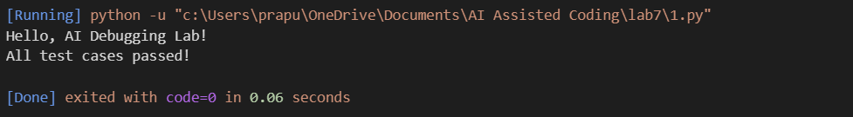

Justification:
"The error occurred because Python 3 requires parentheses with the print() function. GitHub Copilot identified the syntax error and suggested the correction. I then used three assert test cases to verify the expected output, data type, and non-empty result. Since all three tests passed, the corrected program was successfully verified."

Task Description #2: (Incorrect condition in an If Statement) Task: Supply a function where an if-condition mistakenly uses = instead of ==. Let AI identify and fix the issue.
# Bug: Using assignment (=) instead of comparison (==) def check_number(n): if n = 10: return "Ten" else: return "Not Ten"

Prompt:
Find and fix the bug in the following Python code. The if condition incorrectly uses = instead of the required comparison operator. Explain the error, correct the code, and add 3 assert test cases to verify the fix.

Code:
def check_number(n):
if n == 10:
return "Ten"
else:
return "Not Ten"

assert check_number(10) == "Ten"
assert check_number(5) == "Not Ten"
assert check_number(20) == "Not Ten"

print(check_number(10))
print("All 3 test cases passed successfully!")

Output:
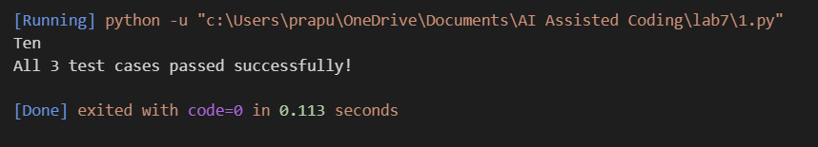

Justification:
The program contained an error in the if condition because the assignment operator was used instead of a comparison operator. In Python, assignment and comparison are used for different purposes, and an if condition requires a comparison. AI identified the error and corrected the condition using the appropriate comparison operator. Three assert test cases were added to verify the function with different inputs. All three tests passed successfully, confirming that the corrected program works as expected.

Task Description #3 :
(Runtime Error – File Not Found) Task: Provide code that attempts to open a non-existent file and crashes. Use AI to apply safe error handling.
# Bug: Program crashes if file is missing def read_file(filename): with open(filename, 'r') as f: return f.read() print(read_file("nonexistent.txt"))

Prompt:
Find and fix the runtime error in the following Python code. The program crashes when the requested file cannot be opened. Use safe exception handling with a try-except block, provide a user-friendly error message, and test the function with a valid existing file, a missing file, and an invalid path.

Code:
def read_file(filename):
try:
with open(filename, 'r') as f:
return f.read()
except (FileNotFoundError, OSError):
return "Error: Unable to open the file. Please check the file path."

with open("test_file.txt", "w") as f:
f.write("Hello, AI Debugging Lab!")

assert read_file("test_file.txt") == "Hello, AI Debugging Lab!"

assert read_file("missing_file.txt") == "Error: Unable to open the file. Please check the file path."

assert read_file("C:\\invalid<>path\\file.txt") == "Error: Unable to open the file. Please check the file path."

print("Test 1 passed: Existing file handled correctly.")
print("Test 2 passed: Missing file handled safely.")
print("Test 3 passed: Invalid path handled safely.")
print("All 3 test cases passed successfully!")

Output:
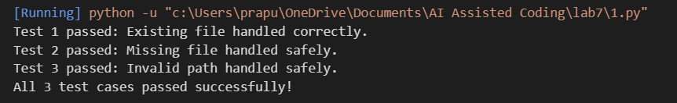

Justification:
The given program attempted to open a file that may not exist, which caused a FileNotFoundError and terminated the program unexpectedly. AI-assisted debugging was used to identify the runtime error and implement safe exception handling using a try-except block. The program was modified to catch file-related errors and display a user-friendly message instead of crashing. Three test cases were added to verify that the program correctly handles an existing file, a missing file, and an invalid file path. All three test cases passed successfully, confirming that the program can handle file errors safely without crashing.
Task Description #4:
(Calling a Non-Existent Method) Task: Give a class where a non-existent method is called (e.g., obj.undefined_method()). Use AI to debug and fix.
# Bug: Calling an undefined method class Car: def start(self): return "Car started" my_car = Car() print(my_car.drive()) # drive() is not defined

Prompt:
Find and fix the error in the following Python code. Identify why the method call fails and determine whether the missing method should be defined or the existing method call should be corrected. Choose the most appropriate solution based on the current class design, explain your decision, and add 3 assert test cases to verify that the corrected class works correctly.

Code:
class Car:
def start(self):
return "Car started"

my_car = Car()

print(my_car.start())

assert my_car.start() == "Car started"
assert isinstance(my_car.start(), str)
assert len(my_car.start()) > 0

print("All 3 test cases passed successfully!")

Output:

Justification:
The program caused an AttributeError because it called a method that was not defined in the Car class. AI identified the issue and suggested using the existing start() method instead. Three assert tests were added to verify the corrected class, and all tests passed successfully.
Task Description #5:
(TypeError – Mixing Strings and Integers in Addition) Task: Provide code that adds an integer and string ("5" + 2) causing a TypeError. Use AI to resolve the bug.
# Bug: TypeError due to mixing string and integer def add_five(value): return value + 5 print(add_five("10"))

Code:
def add_five(value):
return int(value) + 5

assert add_five("10") == 15
assert add_five("5") == 10
assert add_five("20") == 25

print(add_five("10"))
print(add_five("5"))
print(add_five("20"))
print("All 3 test cases passed successfully!")

Output:

Justification:
The program caused a TypeError because it attempted to add a string and an integer. AI identified the type mismatch and provided two solutions: converting the string to an integer for numerical addition and converting the added value to a string for concatenation. Three assert test cases were used to verify each solution, and all tests passed successfully.

